**Backbone Networks**

* High speed networks that link LANs
  + uses high speed circuits
  + allowing information transfer between departments
* Provide connections to other backbones, MANs, WANs, & Internet
* Sometimes referred to as
  + an enterprise network
  + a campus-wide network
* Types:

1. **Serial**
   * + Simplest
     + Connects 2 or more internet working devices by a single daisy-chained cable
     + hubs, gateways, routers, switches, and bridges commonly form part of the backbone
     + Set Standards
       - Define number of hubs allowed
       - Limited hub connectivity
     + Advantages:
       - simple
       - low-cost LAN infrastructure expansion
       - easily attach hubs
     + Disadvantage:
       - not very fault tolerant
       - not very scalable
       - exceeding the standard causes intermittent, unpredictable data transmission errors

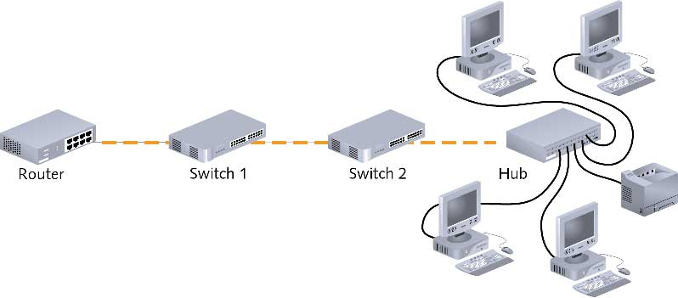

1. **Distributed**

* Snakes throughout a building or campus to provide a connection point for LANs
* Hierarchy of central connectivity devices
* All devices that access this backbone share transmission media
* Advantages:
  + simple expansion
  + limited capital outlay for growth
  + ease of management by network admin
* Disadvantages:
  + single points of failure
  + must be designed to separate network traffic on each LAN from the backbone network traffic

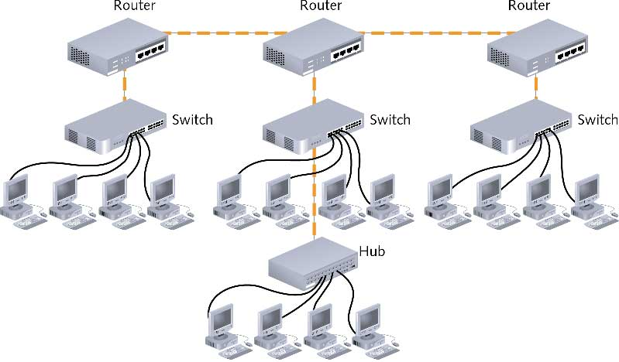

1. **Collapsed**
   * + Uses star topology, usually with a high speed switch at center
     + Single central connection point for multiple subnetworks via router or switch
     + Advantages:
       - has fewer devices
       - centrally manage since the backbone is in a single location
       - allows interconnectivity of different types of subnetworks
     + Disadvantages:
       - requires extra cabling
       - limited distance capabilities - not feasible for multiple buildings
       - risky because failure in central router can bring down entire network

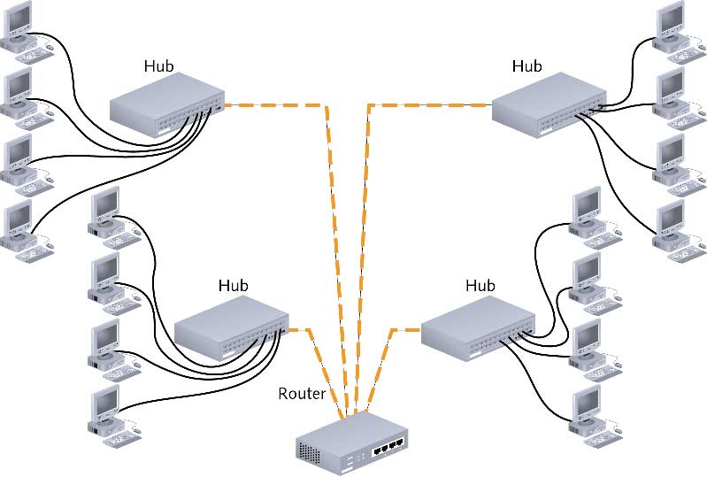

1. **Parallel**
   * + Most robust
     + Consist of more than 1 connection from the central router or switch to each segment
     + Ensures network connectivity to any area of the enterprise
       - Example - Payroll
     + Advantages:
       - redundant
       - increased performance
       - increased fault tolerance
     + Disadvantages
       - more expensive due to additional wiring and hardware

